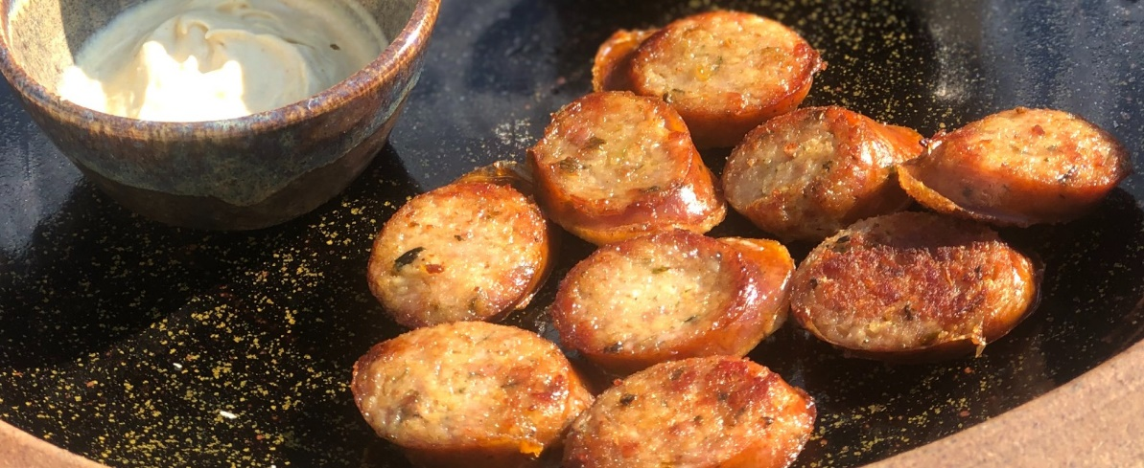
Christmas Smoked Sausage Casserole
.

Serves 4 as a main course

Ingredients
2 carrots (about 100g), cut into thick slices
2 small parsnips (about 80g), peeled, woody cores removed and cut into chunks
1 red onion, cut into wedges
2 tsp olive oil
8 Welsh Dragon Sausages
Dry Cured Free Range Bacon
2 tsp wine or cider vinegar
2-3 tbsp cream or crème fraîche (optional)
2 tbsp chopped soft herbs, such as basil or parsley
mashed potato or leftover roasties (see tip), to serve
Halen Mon Sea Salt and Pepper

Heat the oven to 220C/200C fan/gas 7. Place the carrots, parsnips and red onion into a deep baking or casserole dish, and toss in oil. Season well and roast for 20 mins.
Tightly wrap the Welsh Dragon Sausages in smoked bacon. Add the pigs in blankets and roast for a further 10-15 mins or until the bacon begins to crisp a little.
Reduce the oven to 200C/180C fan/gas 6. Add the vinegar to the baking dish.
Cook for another 40 mins. Taste and adjust the seasoning if needed.
Swirl through the cream, if using, and scatter over the chopped herbs.
Serve with mashed potatoes or leftover roasties.

